**Output-Screenshots**

1.Home Page:

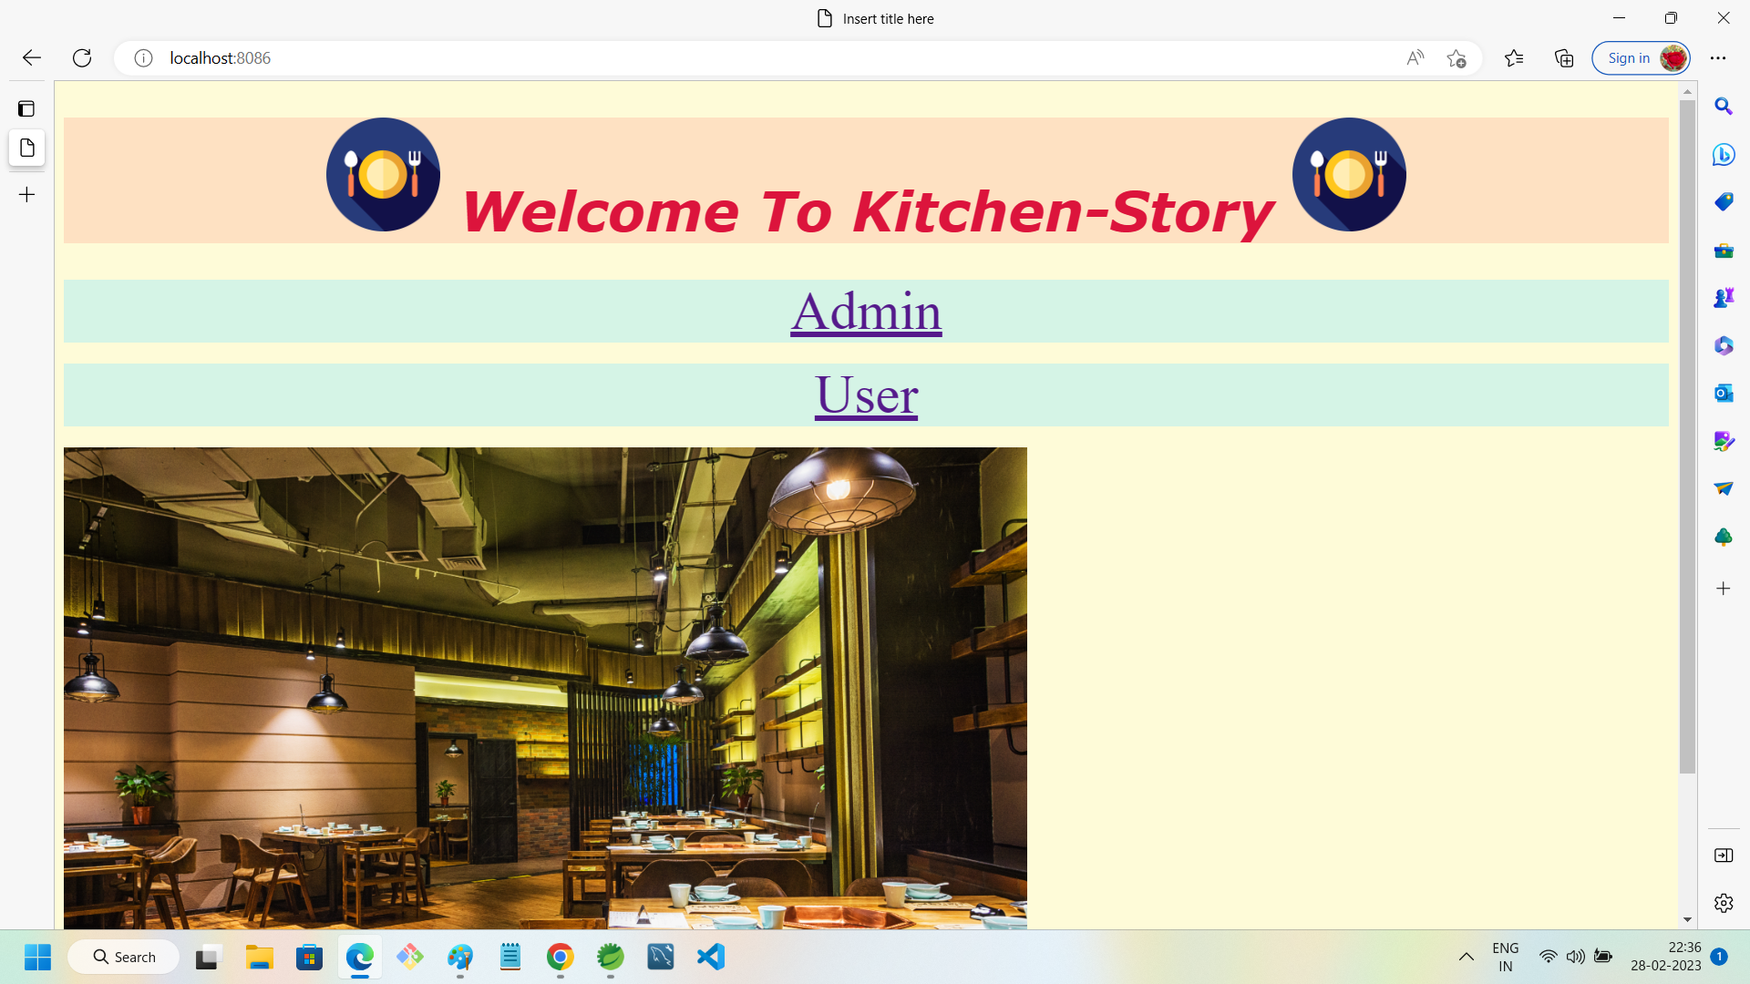

2.Admin-FrontPage:

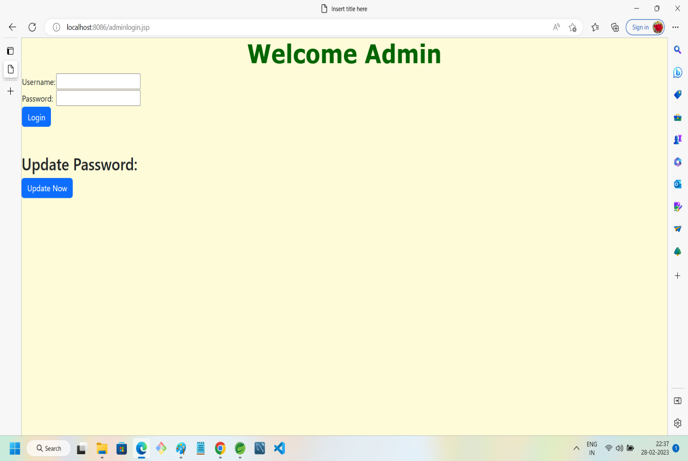

3.Admin Password Update:

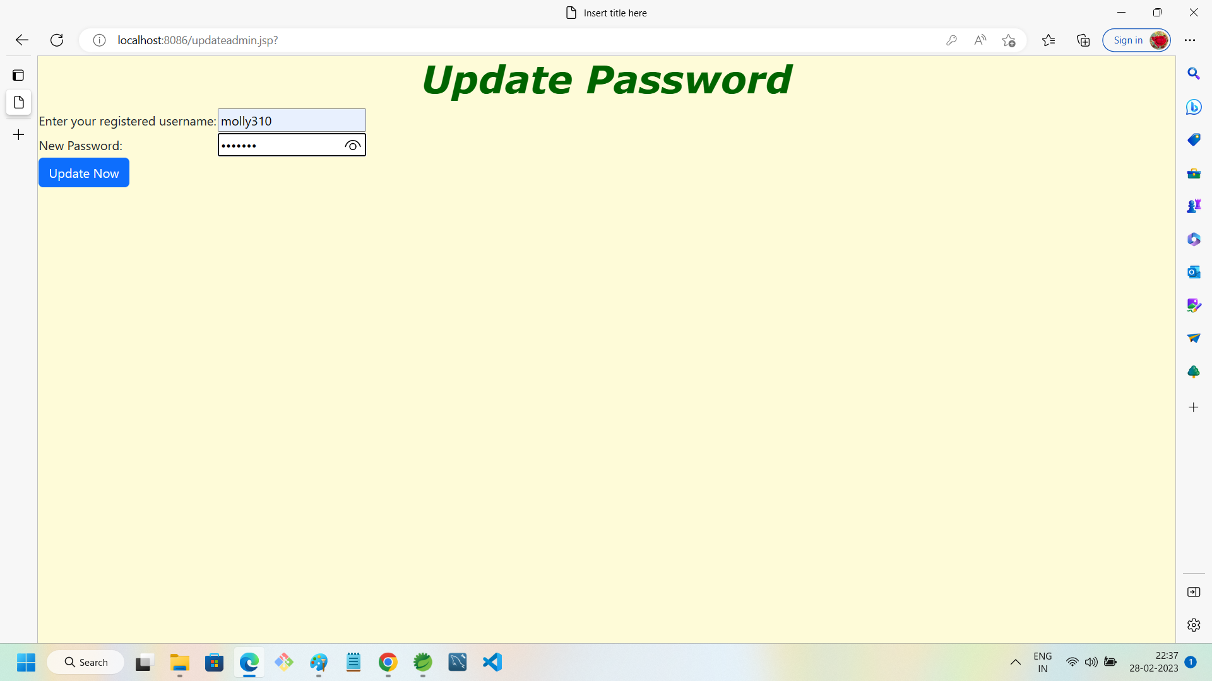

4.Admin Password Updated:

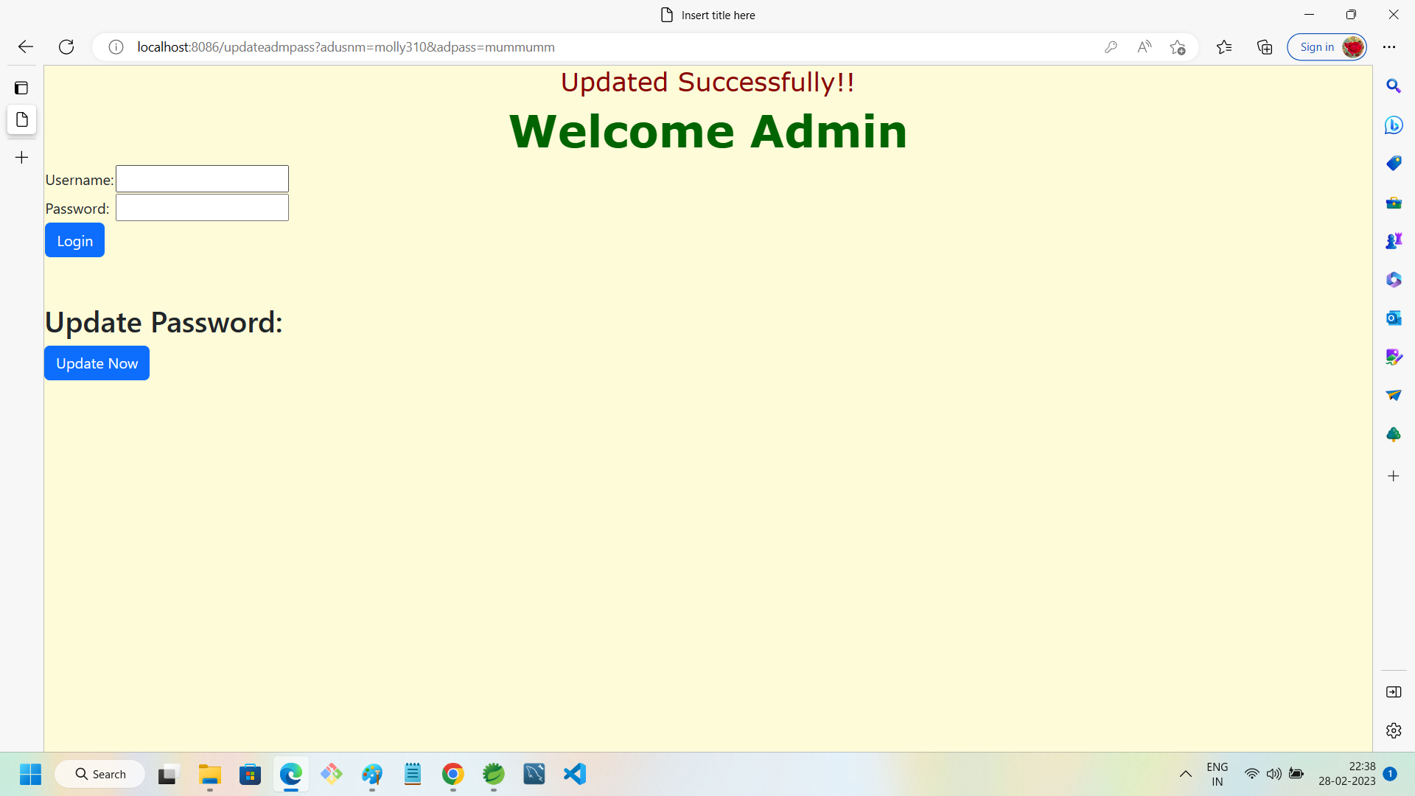

5.Admin Entry Page:

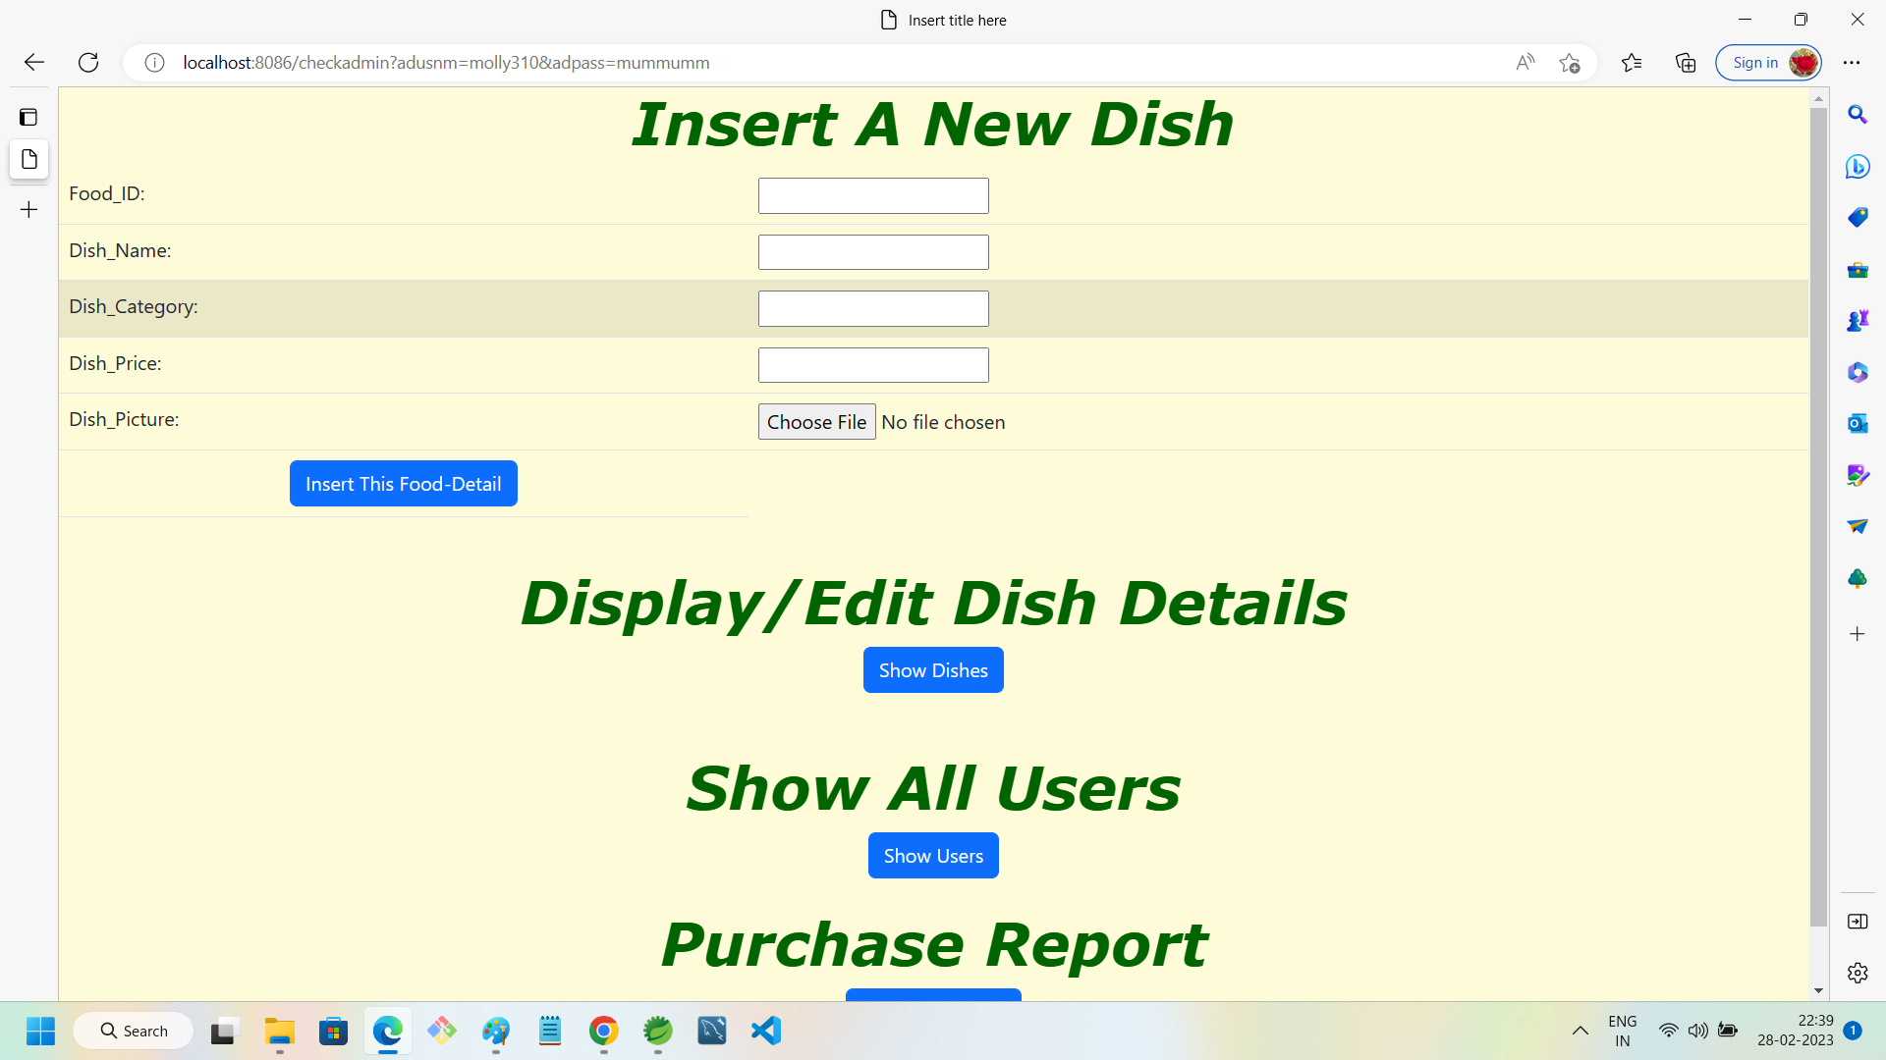

6.Admin Inserting Food Detail:

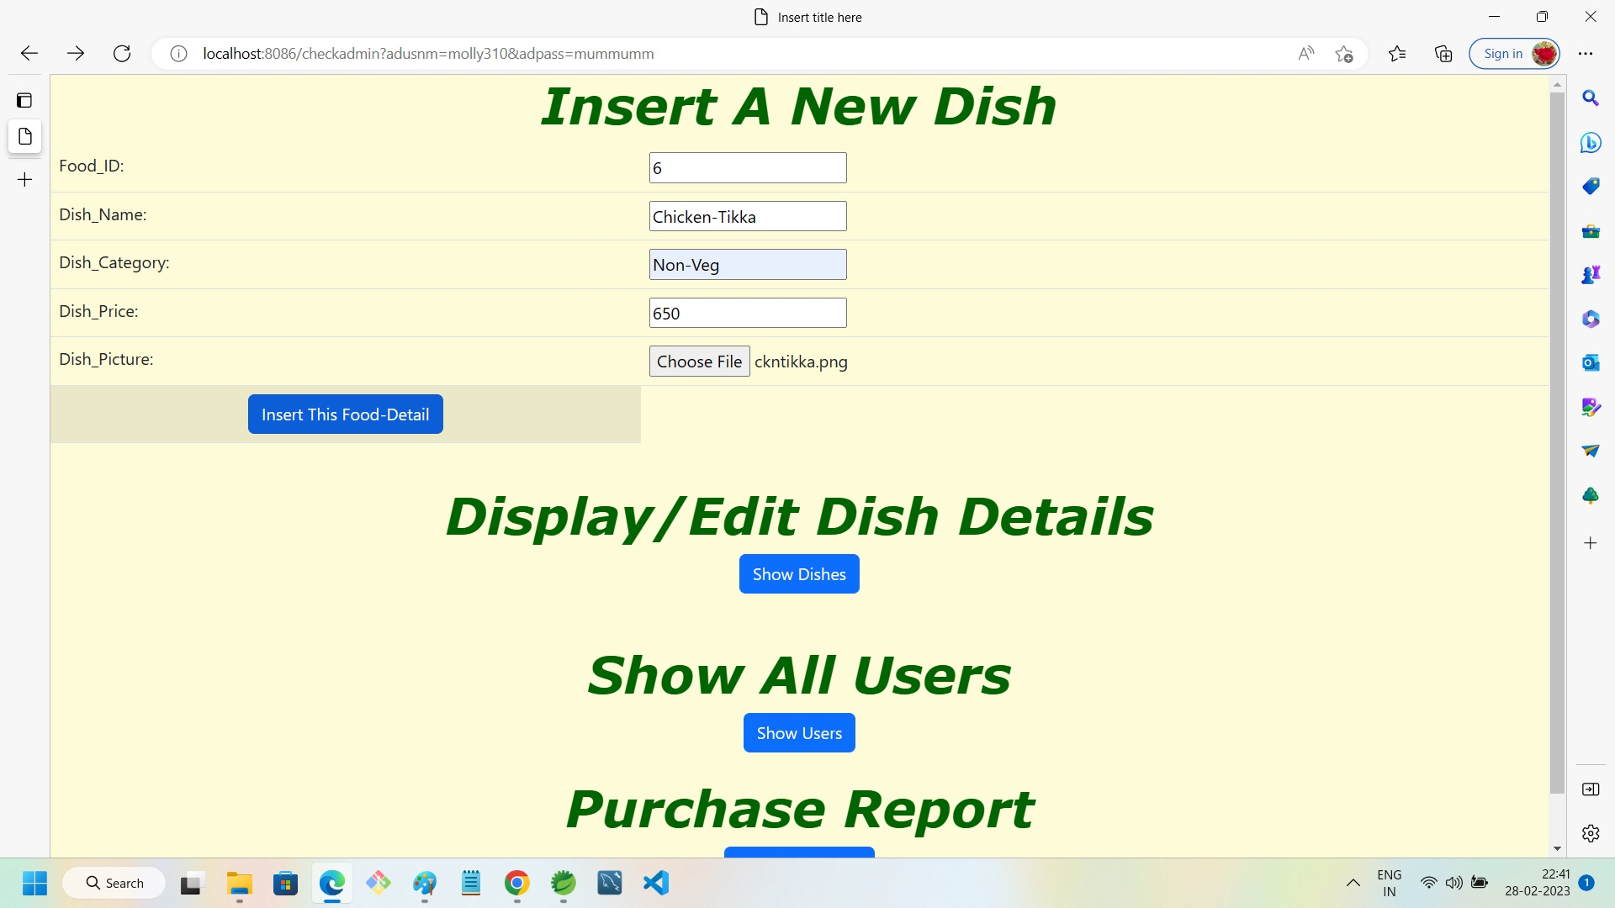

7.Admin Food Item Display With Edit-Delete Option:

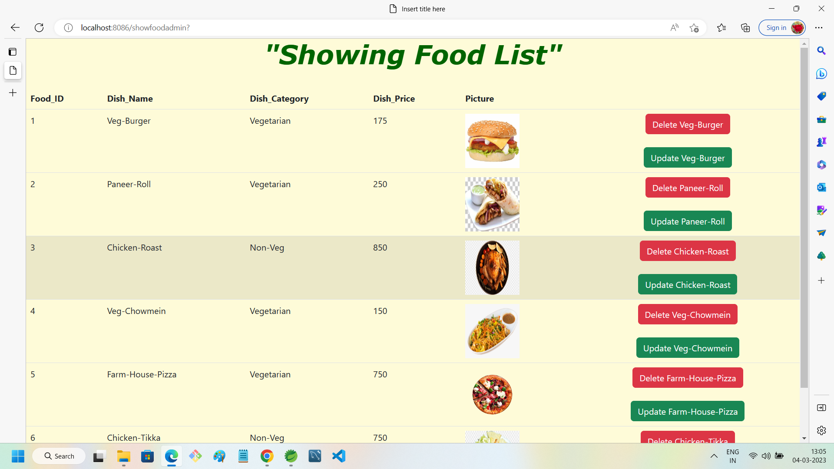

8.Displaying List of Users For Admin:

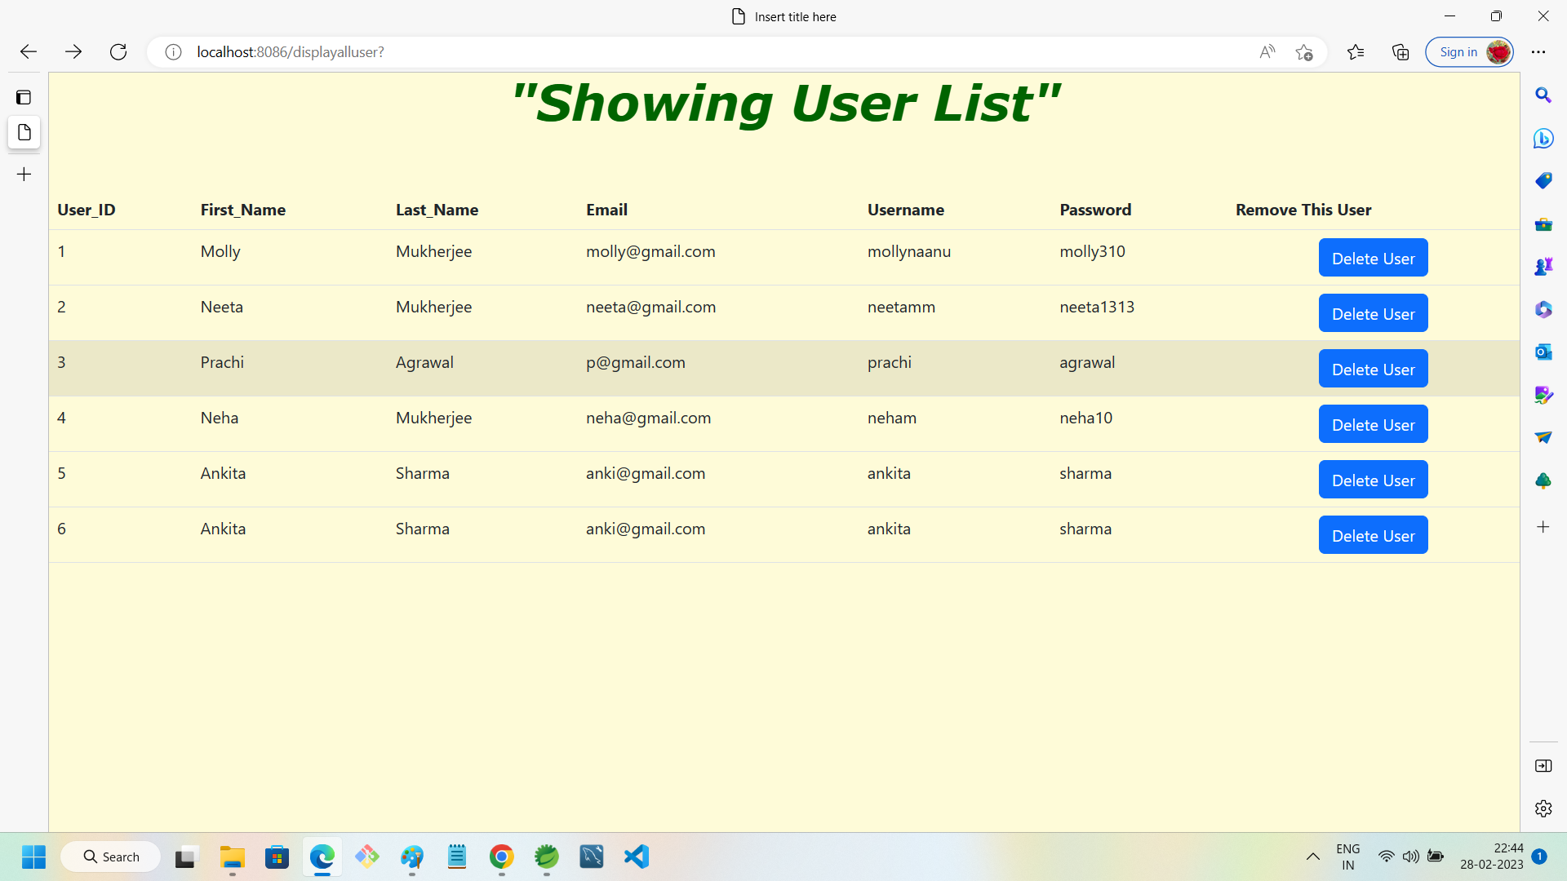

9.Purchase Report for Admin in case of successful Payment by User:

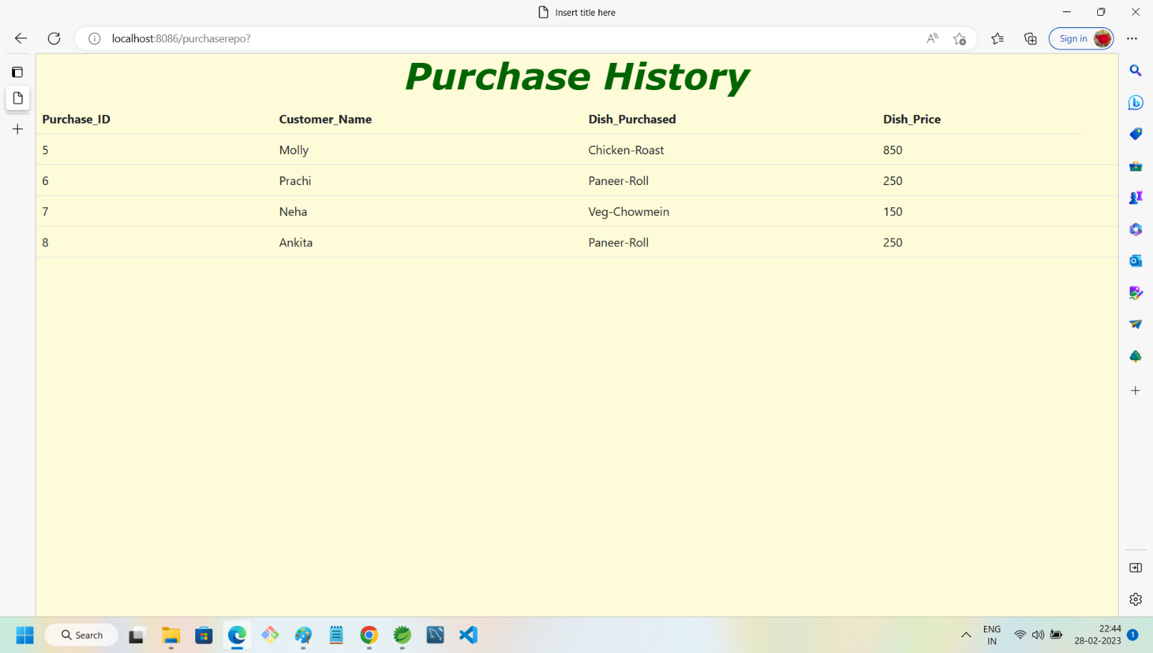

10.User Entry Page:

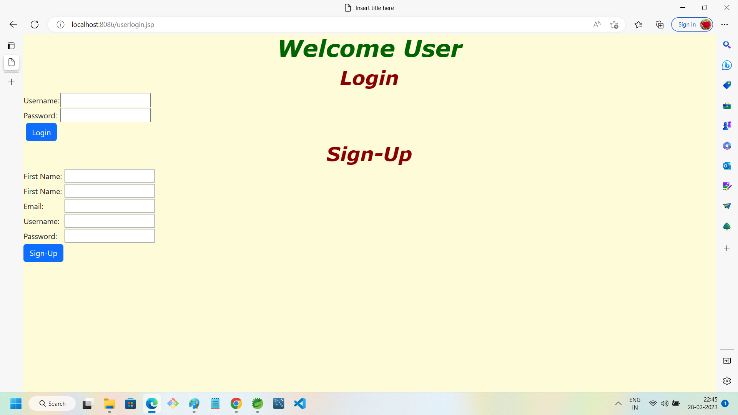

11.User’s wrong Password entry:

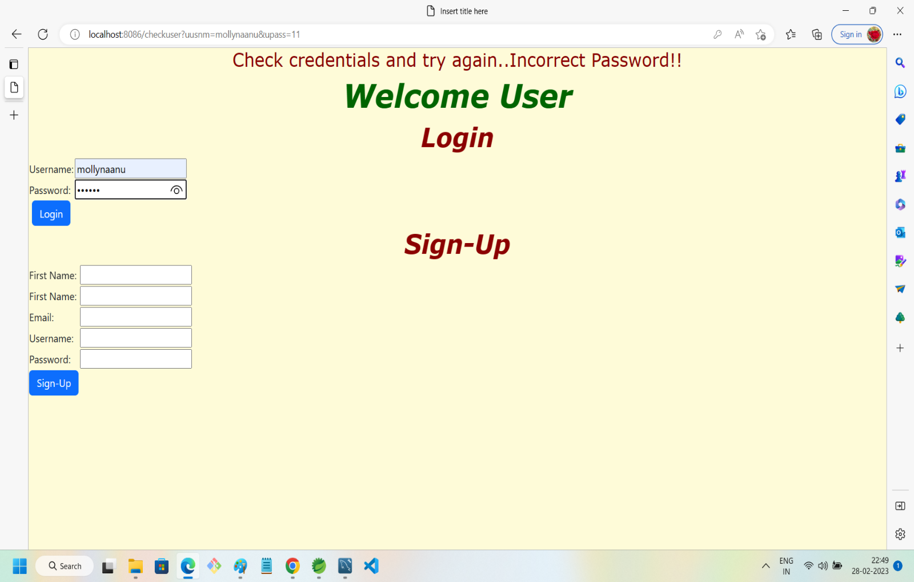

12.User Not registered and trying to Login:

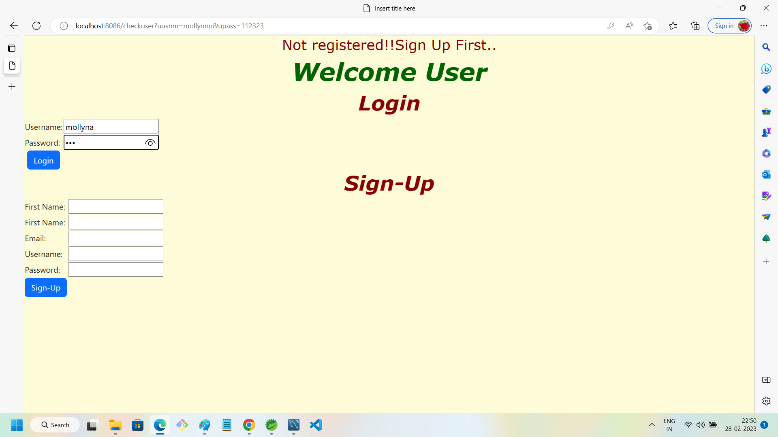

13. Welcome user:

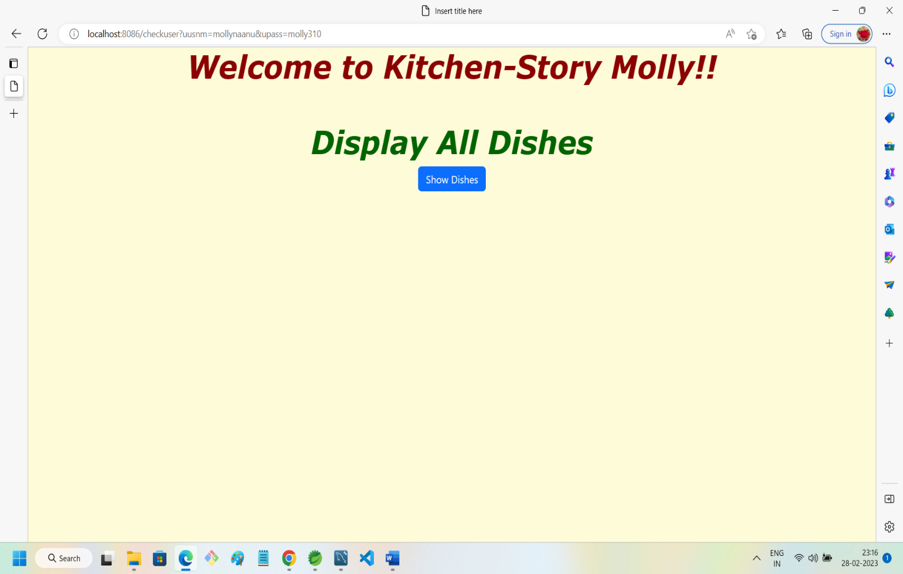

14.User food list display with SEARCH option:

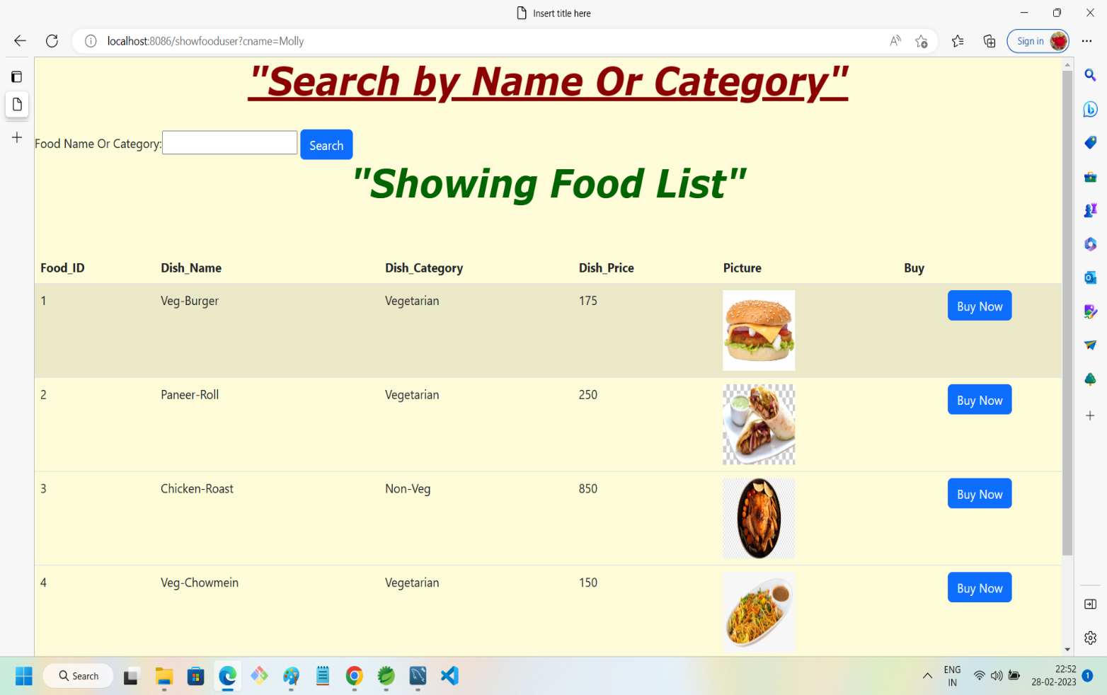

15.User searching for food or category:

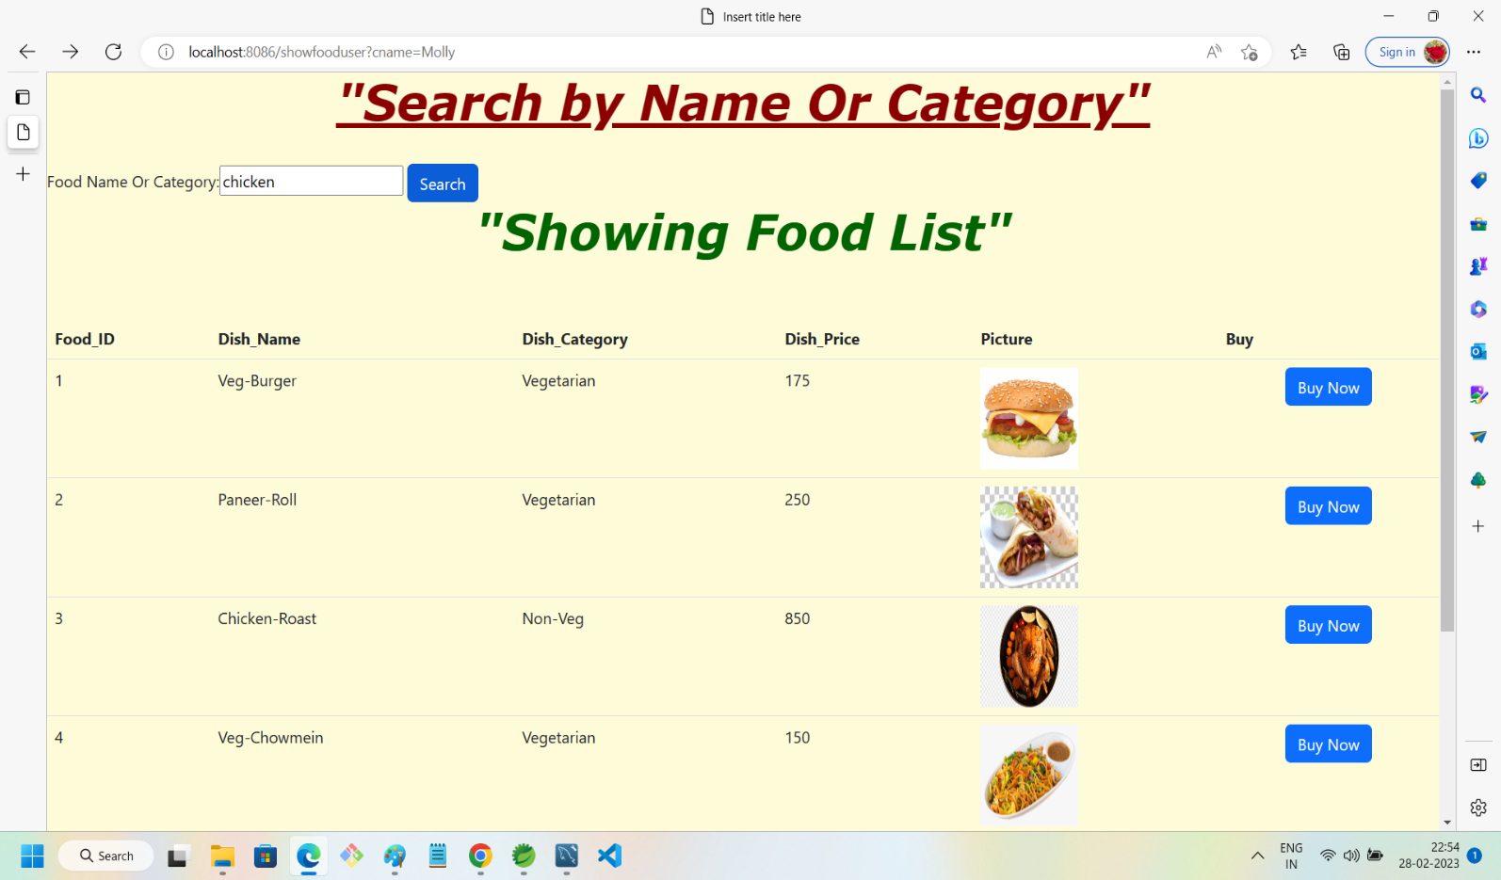

16.Food Search Result:

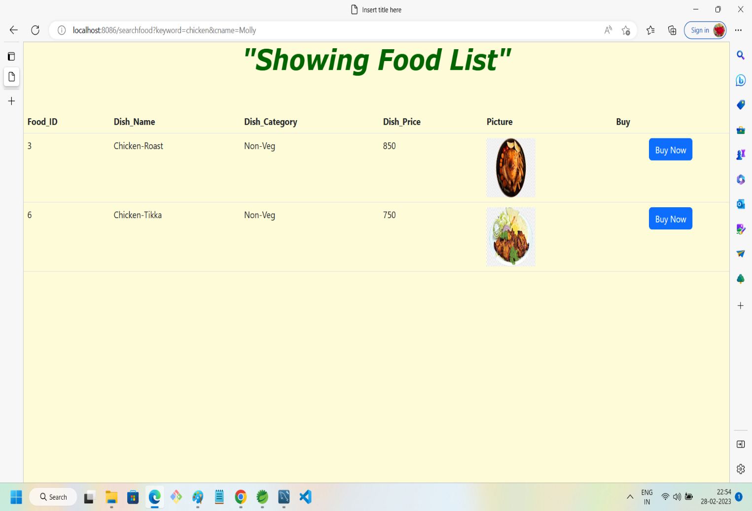

17.Pressing Buy Button:

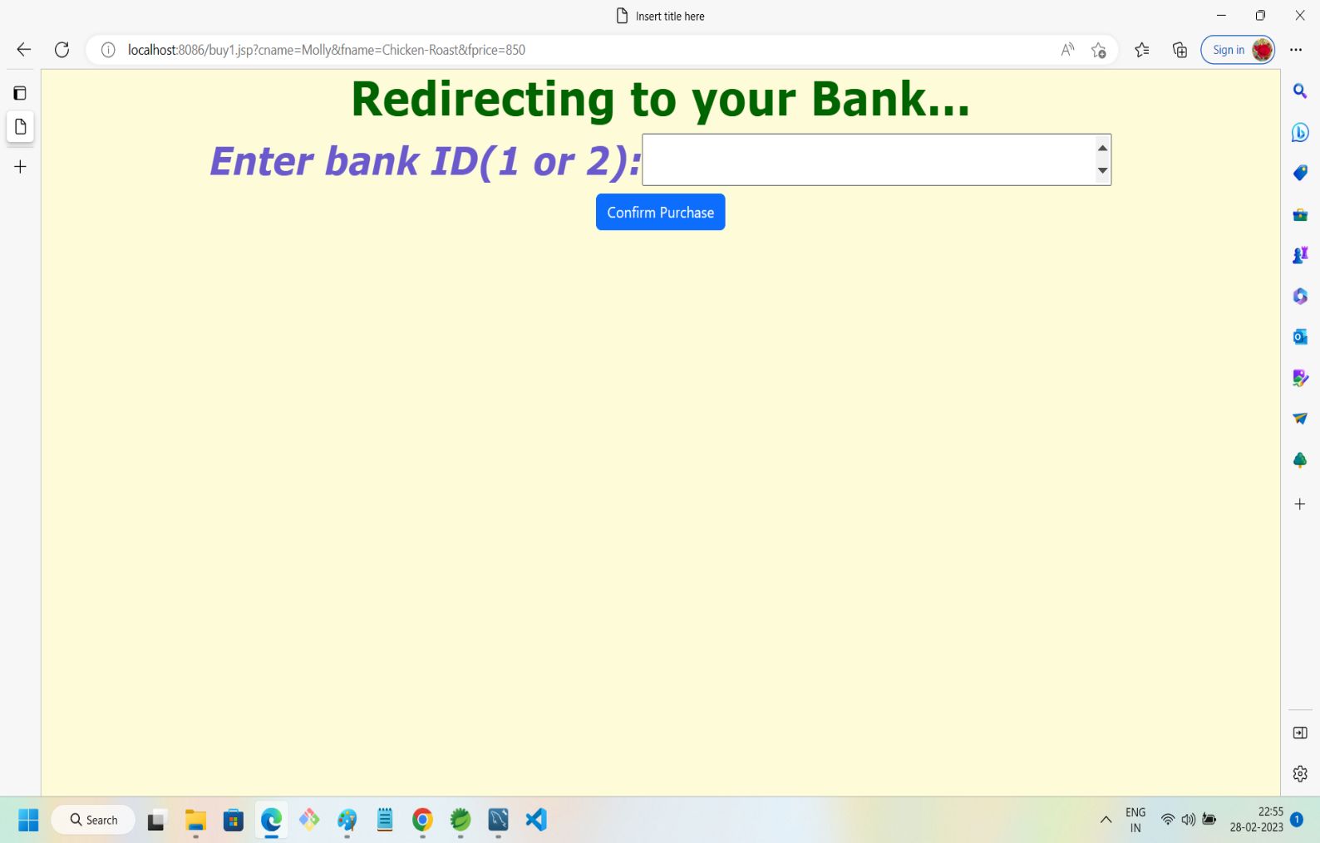

18.Payment successful in case of sufficient balance:

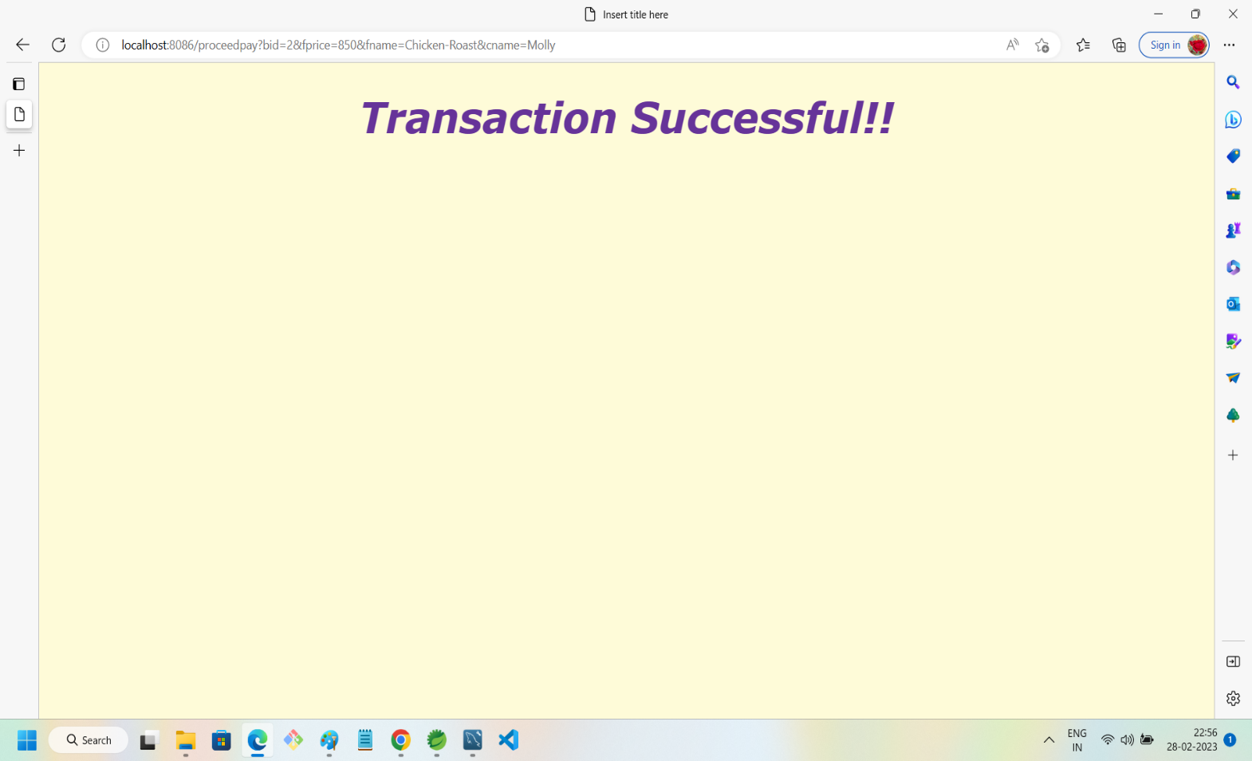

19.Failed payment case:

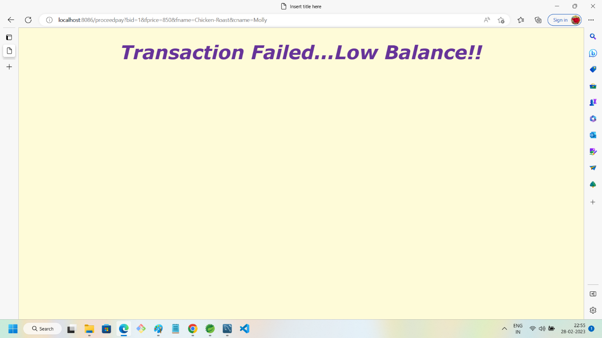

20.Admin registration via backend(POSTMAN):

